- Alexa Splagounias  - ED 948 Policy Brief  27 March 2019 | Improving Teacher Preparation Programs to Properly Equip Preservice Teachers to Support Children with Special Needs in the Classroom
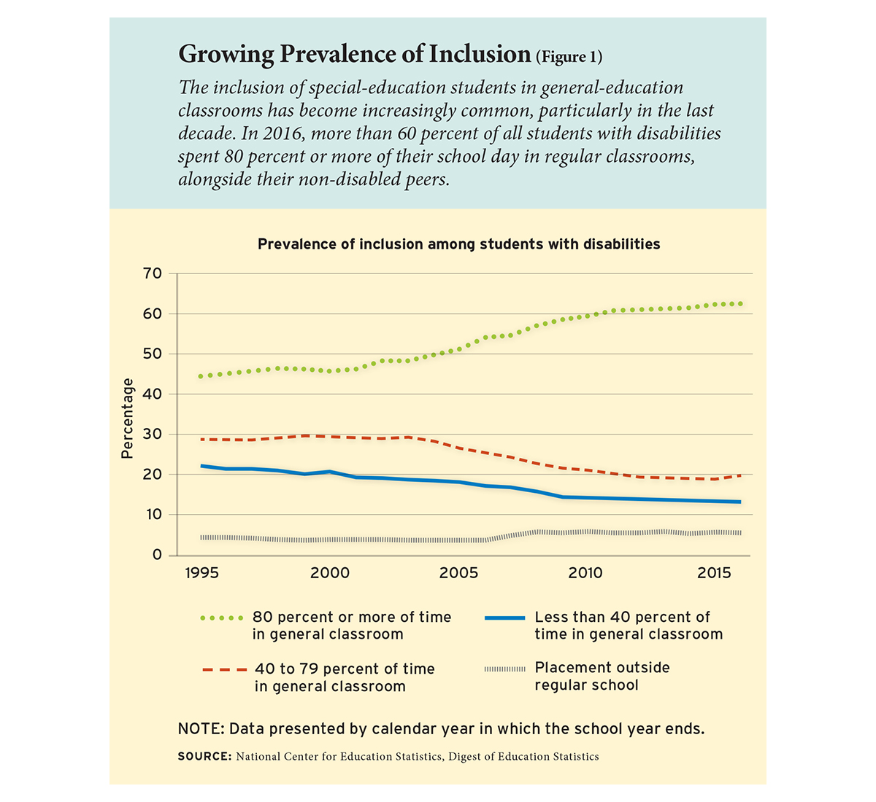  Increased Classroom Teacher Responsibilities  With the increased prevalence of inclusion of children with special needs, comes increased responsibilities for classroom teachers. Now, general education classroom teachers are expected to take on a larger, more lead role in the education of children with special needs. The responsibility now falls on them to create and implement accommodations to support children with special needs in their classroom on their own, without having the proper special education training to do so. The responsibilities of classroom teachers now resemble more of what used to be the responsibility of special education teachers. But yet, there is a lack of special education training for general education teachers within their preservice teacher preparation programs. | Providing proper training and education to preservice teachers in their teacher preparation programs then they will enter the field feeling well prepared to support the needs of all students in the classroom, which will in turn lead to teachers having more positive views on inclusion and improved student learning outcomes.  Related Policies  IDEA: The Individuals with Disabilities Education Act (IDEA) is the policy governing special education services in New Hampshire. Under section 1412. State Eligibility part (a)(1) and (5)(a), children with special needs are entitled to a free appropriate public education in their least restrictive environment. But, are all children really receiving an appropriate education in their least restrictive environment, which is most often the general education classroom, if general education classroom teachers are not being properly trained to support the needs of all students within the classroom?  Chapter Ed 600 of Professional Preparation Programs: Chapter Ed 600 of Professional Preparation Programs provides a set of standards for which teacher preparation programs must abide. Ed 6012.03 section (b)(c)(1) provides that teacher preparation programs in early childhood education shall provide the teaching candidate with the following skills, competencies, and knowledge through a combination of academic and supervised field experiences in the area of child development and learning in the ability to (b) use understanding of the multiple interacting influences on children’s development and learning to. Individualize their planning and instruction; and (c) create environments that are healthy, respectful, supportive, and challenging for all children, including, but not limited to, children: (1) with developmental delays or disabilities. But, the requirements of current teacher preparation programs for general education teachers do not allow teachers to truly individualize planning and instruction, as well as create environments that are healthy, respectful, supportive, and challenging for all children, as there is very little education on special education within current teacher preparation programs.  Introduction Inclusion of children with special needs into the general education classroom is becoming more and more prevalent. Roughly sixty percent of students with disabilities spend more than eighty percent of their day in general education classrooms. Further, roughly ninety- six percent of general education teachers have students with special needs in their classroom. Despite the increased prevalence of inclusion within schools and policies to support that, our teacher preparation programs are not reflective of these changes. The school system is everchanging and it is important that our policies and teacher preparation programs mirror that.
Sources
State Approval of Educator Preparation Programs (2001). PsycEXTRA Dataset. doi: 10.1037/e417962005-001
Department of Education. (2019, March 12). Menu. Retrieved from http://sites.ed.gov/idea/statute-chapter-33/subchapter-II/1412
Peterson-Ahmad, M. B., Ph.D., Hovey, K. A., Ph.D., & Peak, P. K., Ph.D. (2018, June). Pre-Service Teacher Perceptions and Knowledge Regarding Professional Development: Implications for Teacher Preparation Programs. Retrieved from The Journal of Special Education Apprenticeship.
Fuchs, W. W. (2010). Examining Teachers' Perceived Barriers Associated with Inclusion. Retrieved from SRATE Journal.

Recommendations
My recommendations to prepare teachers to support the needs of all students in the classroom includes, adding additional special education training in teacher preparation programs.
More specifically, I feel that teacher preparation programs would benefit from including addition courses in special education on differentiated instruction, inclusion, Universal Design for Learning (UDL) and special education laws.
Additionally, including an internship placement in which preservice teachers gain experience in working with and designing curriculum to support children with special needs would be very beneficial to preparing preservice teachers.
I also recommend providing increased professional development opportunities for preservice and in-service teachers to learn strategies to support children with special needs.
Overall, I recommend consistency between training for special education and general education teachers, in preparing all teachers to be equipped with the necessary knowledge and skills to support the needs of all students within the classroom.

Conclusions
In conclusion, the field of education is constantly evolving and changing, and our practices and education for teachers needs to be reflective of that.
If we provide proper training and education to preservice teachers within their teacher preparation programs, then they will enter the field well prepared to support the needs of all students within their classrooms. This in turn will lead to teachers entering the field with a more positive view towards inclusion and ultimately lead to improved student learning outcomes.
Teachers need to be equipped with the necessary training and skills to be able to effectively support the needs of all students in the classroom.
It is the role of preservice general education teacher preparation programs to instill the importance of inclusion and to provide the necessary skills to teachers to be able to differentiate and individualize instruction to meet the needs of all students in the classroom, particularly those with special needs.
The potential to lead to adverse effects on student learning amplifies the need to properly train preservice teachers on how to support children with special needs. Teachers need to know how to individualize instruction to the greatest extent possible in order to promote success of each and every one of their students.

Stakeholder Perspectives
The main stakeholder perspectives on the issue of the training preservice teachers in special education include pre-service and in-service general education teachers, pre-service and in-service special education teachers and administrators.
Administrators: Administrators perceive the lack of special education training in preservice teacher preparation programs to be an important issue in that they believe it is essential for all teachers to be well equipped with training and strategies to support a wide range of learners upon entering the education field. They want teachers who are able to support the needs of all students in the classroom.
Preservice Teachers: Preservice teachers express desire and feel that it is important to be trained and educated on how to effectively support the diverse needs of all students in the classroom, including those students with special needs.
In- Service Teachers: In-service teachers express feelings of frustrations by their lack of training and preparedness to support children with special needs in the classroom. They feel that training in special education is important. As a result of feeling ill prepared to support children with special needs in the classroom, teachers develop frustrations, leading to negative views towards inclusion. Teachers develop negative views towards inclusion stem from a lack of preparedness, exposure, support and training in special education. Teachers’ beliefs about inclusion are directly correlated to their actions and behaviors in the classroom and towards those students, as well as the students’ learning. Teachers’ negative attitudes towards inclusion can lead to adverse effects on student learning outcomes.

